1)using python pip command create a requirement.txt file from the terminal/command-prompt of your a system?

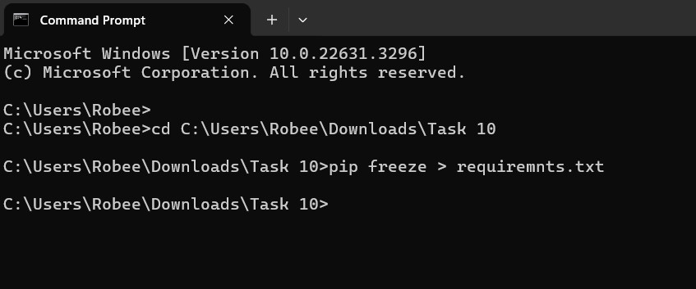

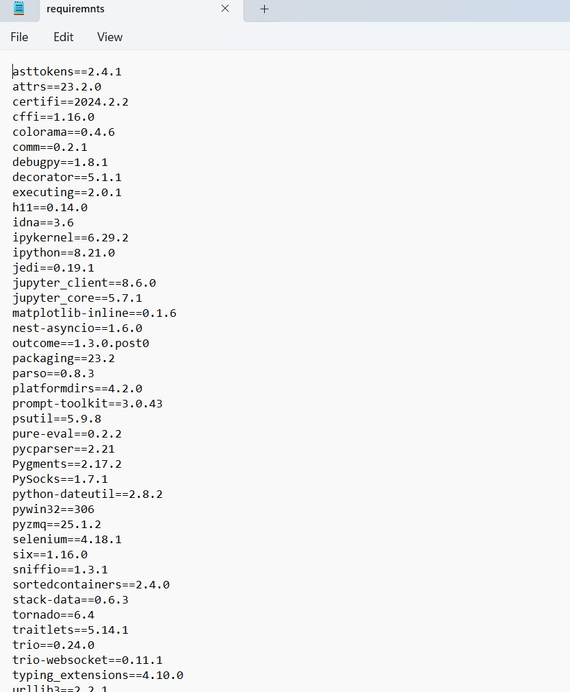

2)Using the python pip command install the flask module <2.0

